
Southern Utah University
General Biology I
Scientific Literature Review

Name: Alexander Cannell

Topic: Systematics

Title (1 pt): Paternal Influences on Children’s Weight Gain: A Systematic Review

Author(s) (1 pt): Josephine Fraser, Helen Skouteris, Marita Mccabe, Lina A. Ricciardeli, Jeannette Milgrom, and Louise A. Baur.

Date Published (1 pt) Fall 2011
Full Journal Name (1 pt): Fathering: A Journal of theory, Research, and Practice about Men as Fathers.

Pages (1 pt): Pages 252-267

Series/Volume (1 pt): Volume 9 Issue 3

Write the citation using the APA format (1 pt) :
Fraser, J., Skouteris, H., Mccabe, M., Ricciardelli, L. A., Milgrom, J., & Baur, L. A. (2011). PATERNAL INFLUENCES ON CHILDREN'S WEIGHT GAIN: A SYSTEMATIC REVIEW. Fathering: A Journal Of Theory, Research, & Practice About Men As Fathers, 9(3), 252-267.

What question or hypothesis was addressed by the publication? (1 pt)

What is the case of Childhood obesity, and what can parents do to prevent their children from being obese?

How was the question or hypothesis addressed? (1 pt)
They went through 10 case studies and found 8 probable reasons of childhood obesity. Out of those 8 probable reasons, they found three reasons that were in most of the case studies Parental Eating and Children’s activity Practices, Parental Parenting Styling, and Parental Feeding Practices. So they concluded that the way the parents are parenting their obese children is a major case of childhood obesity. They addressed all three of these parenting reasons, to help parents change their children’s or help prevent their children’s obesity problem. The key thing is the children mimic the eating habits of their parents, and their activity fails as a result. Their hypothesis was supported.

Attach copy of first page (1 pt)
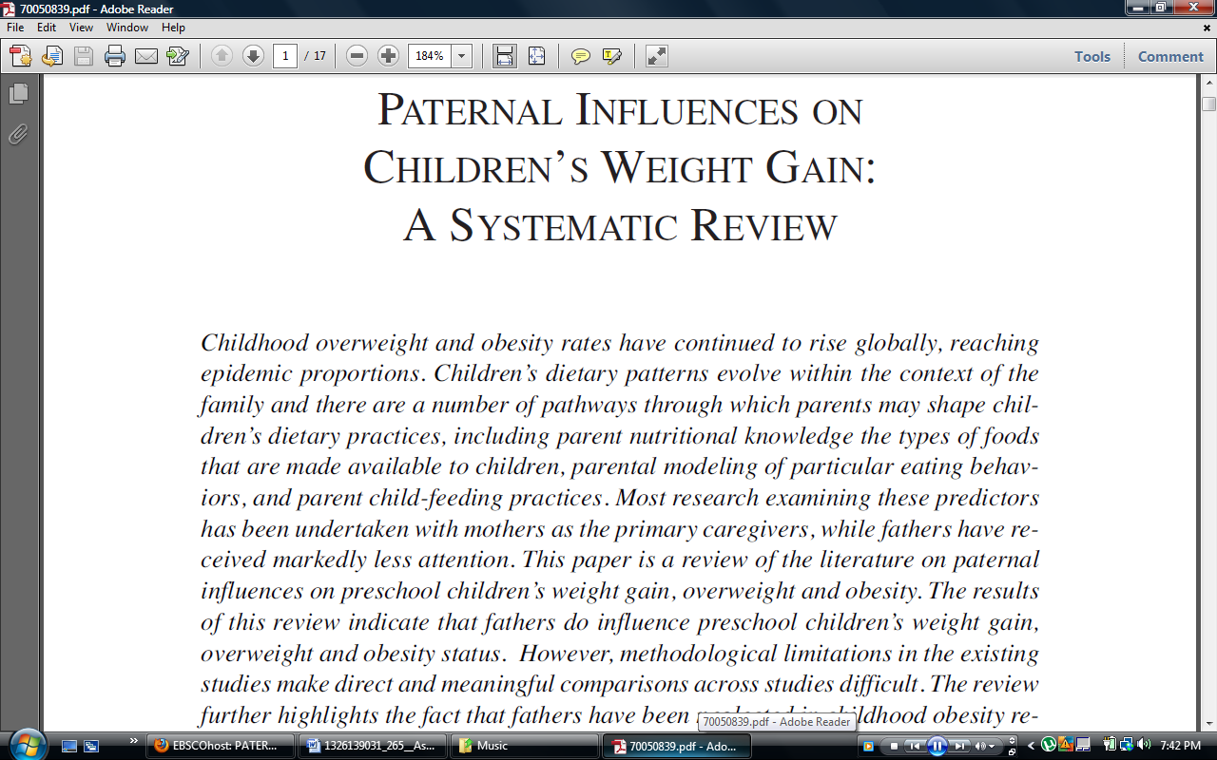
http://web.ebscohost.com.proxy.li.suu.edu:2048/ehost/pdfviewer/pdfviewer?sid=7fb11129-d31c-481e-bb8d-91f4109d7faf%40sessionmgr15&vid=5&hid=12

